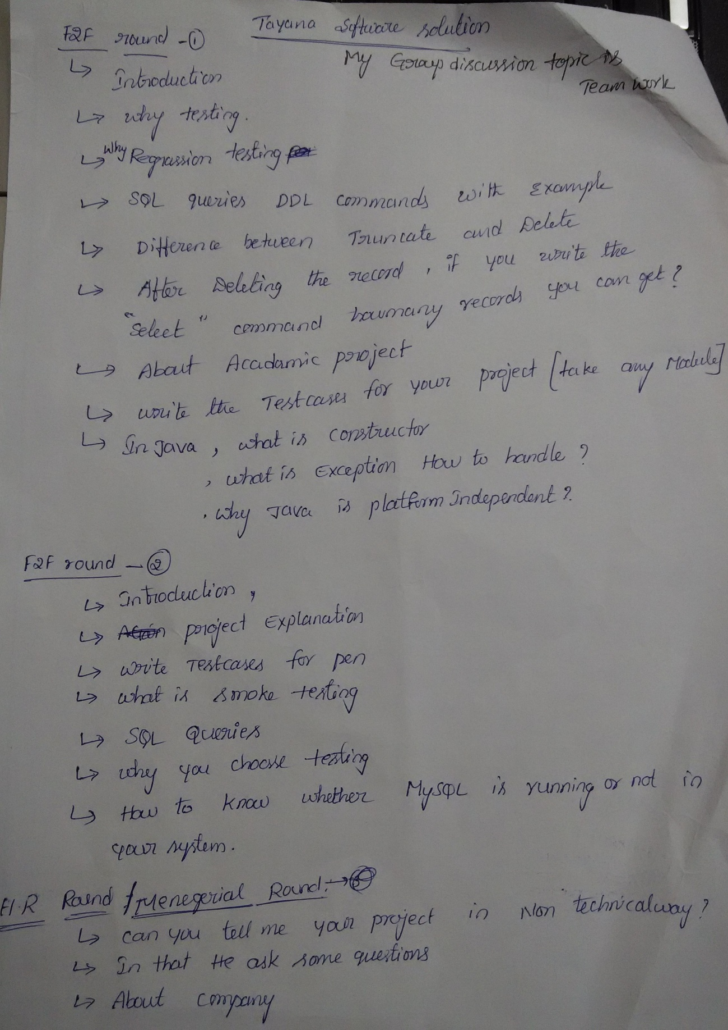

Questions mostly **on your favorite subject** in my case DBMS and C since it was my favt subject.

MCQs contained output based C questions... Technical round consists of questions on C, DBMS, problem solving.

* Tell me about yourself?
* Your favorite subjects?
* Indexing in DBMS?
* Triggers and its type?
* Constraints in DBMS.
* Can you overload print function in c…?
* Read a string and reverse it without string header in c? Linked list in c.
* Difference between http and https?
* What is web server?
* Functionality of web server.
* Basic electronics...especially digital electronics
* Output of a particular digital eckt
* Academic Project